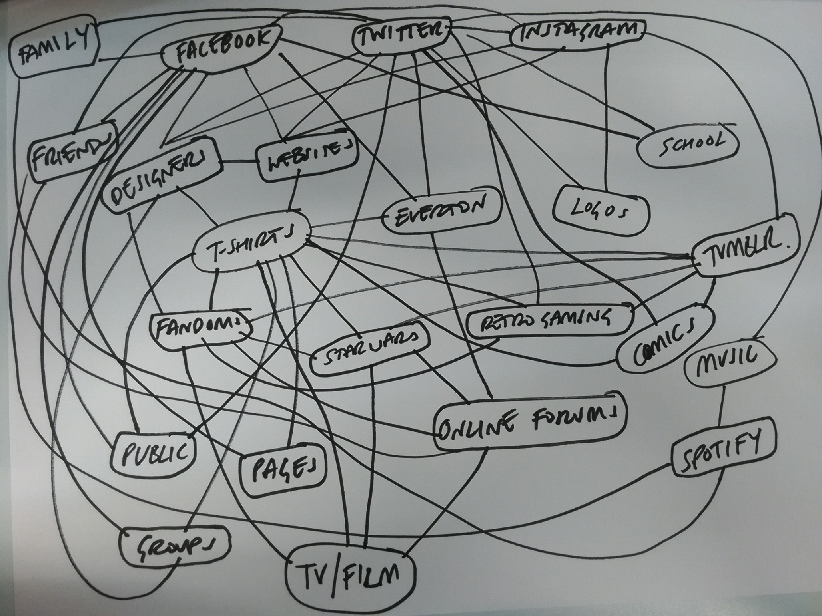­­­­

Starter:

Write down as many words that you feel define you, try to create a sentence that sums you up. Think about your personality, interests, hobbies and achievements.

**Task 1**  
 **We live in a connected world, we use apps to record, share and follow things on a daily basis.**   
These apps and websites required registration; this means the content you post is linked directly to you. Thinking about all the apps that you use - list them down in the space below.

**On the back of this sheet mindmap the links from interests to apps, websites and so on. There is an example above**

**Task 2**

Our connected world map needs to show how we are actually connected, in another colour pen extend your map to add connections to other people (family, friends, others)

**Plenary**

How do you think someone online would describe you? What do your online apps and comments say about you? How do is this different from the words you used for the starter?